# 

Contents

Topic Working with Relationships 2

Relationship View 2

1. Scenario 2

a. Data Set 3

b. Class Example 3

2. Video 4

Topic Calculated Columns– 4

1. Basic Usage- 4

2. Scenario 4

a. Class Example- 4

3. Video 5

Topic Calculated Measures– 5

Basic Usage- 5

1. Scenario 5

a. Class Example- 6

Class Questions-

Open PowerBI Desktop and Import data from the view Sales.vSalesPerson found in AdventureWorks.

1. In the Query Editor: Replace the null values with a Blank

Remove the column AddressLine 2

The column SalesLastYear needs to be rounded to 2 decimal places

1. Close and Apply. Using the view What Country has the most Sales Reps

Topic Working with Relationships

– In this section we will look at how you can do more advanced data modeling tasks using the Power BI Desktop. One of the great things about Power.BI compared to some other tools is that you don’t need to flatten all of that data that you are pulling in to a single table; you can leave it in separate tables and just define the links between them to help make it easier to do that modeling.

Relationship View – shows all the tables, columns, and relationships in your model. This can be especially helpful when your model has complex relationships between many tables.

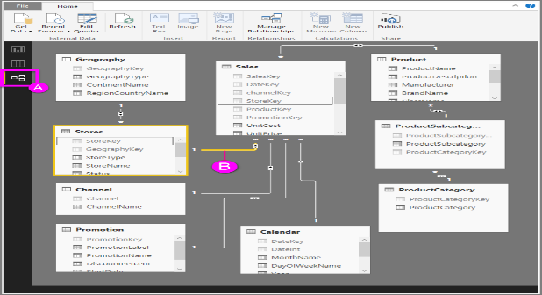

**A.**  Relationship View icon – Click to show your model in Relationship View

**B.** Relationship – You can hover your cursor over a relationship to show the columns used. Double-click on a relationship to open it in the **Edit Relationship** dialog box.

In the figure above, you can see the *Stores* table has a *StoreKey* column that’s related to the *Sales* table, which also has a *StoreKey* column. We see it’s a *Many to One* (*:1) relationship, and the icon in the middle of the line shows the Cross filter direction set to *Both*. The arrow on the icon shows the direction of the filter context flow.

1. Scenario – When you import multiple tables, chances are you’re going to do some analysis using data from all those tables. Relationships between those tables are necessary in order to accurately calculate results and display the correct information in your reports. Power BI Desktop makes creating those relationships easy. In-fact, in most cases you won’t have to do anything, the Autodetect feature can do it for you. However, in some cases you might have to create relationships yourself, or you might need to make some changes to a relationship. Either way, it’s important to understand relationships in Power BI Desktop and how to create and edit them..
   1. Data Set – Load the Section 2 class.pbix file

(One Drive link- <https://1drv.ms/u/s!AgsRLppxitDjgR2w3viq0-nxNhI4> )

* 1. Class Example – After loading the excel file click on the Relationship View

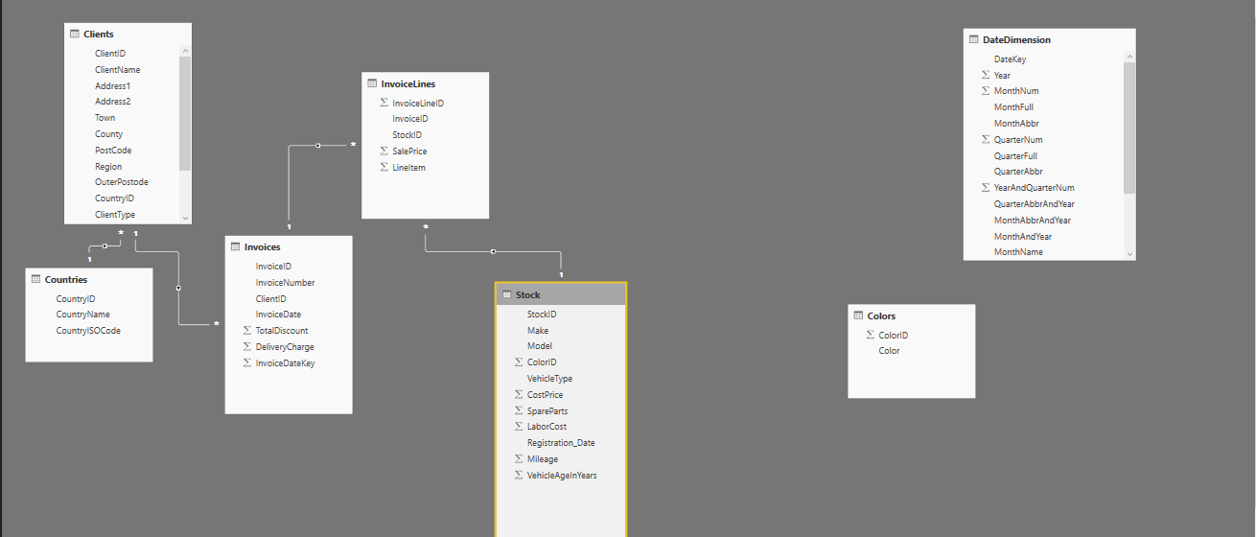

I can see my Countries and Clients tables have got a relationship and the Invoices and InvoiceLines tables. Adding and removing these relationships is simple. If I just select the relationship, right-click it and hit Delete, I can remove them. And creating them is as simple as dragging and dropping the fields that you want between these tables.

You can do a few more things through this relationship view. Things like hiding these

tables as well.

Go to report view, select the **Model** from the Stock table and **Color** from the Colors table. When there is not a defined relationship Power BI has solutions to fix the problem. If the item can’t be displayed, click on “FIX THIS” for assistance and then autodetect.

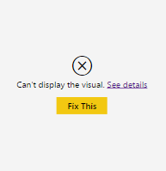 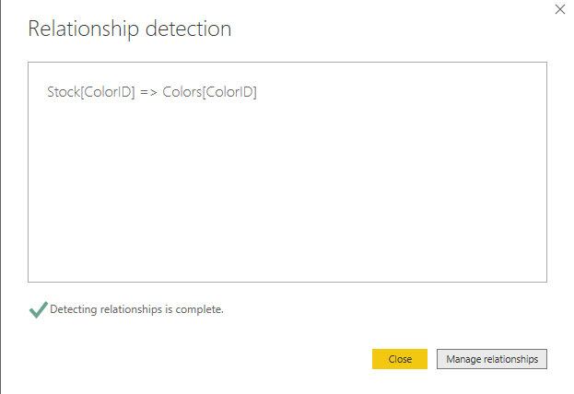

** Example: DateDim(DateKey) to Invoice(InvoiceDate? What about the datatype)

# Topic Calculated Columns–

With calculated columns, you can add new data to a table already in your model. But instead of querying and loading values into your new column from a data source, you create a Data Analysis Expressions (DAX) formula that defines the column’s values. In Power BI Desktop, calculated columns are created by using the New Column feature in Report View.

1. Basic Usage- calculated columns created in Report View or Data View are based on data you’ve already loaded into the model. For example, you might choose to concatenate values from two different columns in two different but related tables , perform addition, or extract sub-strings.
2. Scenario - Jeff is a shipping manager at Shaddy Outlaws. He wants to create a report showing the make and model of the cars. He has a Stock table with separate fields for Make and Model. But, Jeff wants his reports to show Make and Model as a single value on the same row. Right now, Jeff’s Stocks table doesn’t have the field he wants.

Dax Basic

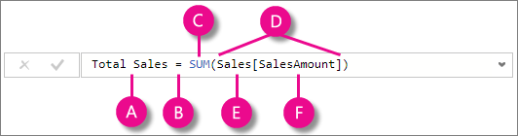

This formula includes the following syntax elements:

**A.** The column name **Total Sales**.

**B.** The equals sign operator (**=**) indicates the beginning of the formula. When calculated, it will return a result.

**C.** The DAX function **SUM** adds up all of the numbers in the **Sales[SalesAmount]** column. You’ll learn more about functions later.

**D.** Parenthesis **()** surround an expression containing one or more arguments. All functions require at least one argument. An argument passes a value to a function.

**E.** The referenced table **Sales**.

**F.** The referenced column **[SalesAmount]** in the Sales table. With this argument, the SUM function knows on which column to aggregate a SUM.

* 1. Class Example- In the table Stock create a new column that combines the Make and Model with an ‘_’ in between. Right click on the ‘…’ in the Stock table. Select New Column and combine the two columns using Dax.

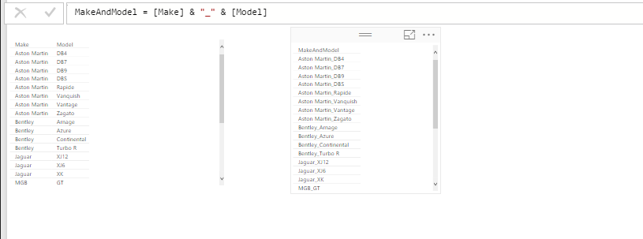

# Topic Calculated Measures–

Measures are used in some of the most common data analysis; for example, sums, averages, minimum or maximum values, counts, or more advanced calculations you create yourself using a DAX formula. The calculated results of measures are always changing in response to your interaction with your reports,

Basic Usage-

Measures calculate a result from an expression formula. When you create your own measures, you’ll use the [Data Analysis Expressions](https://msdn.microsoft.com/library/gg413422.aspx) (DAX) formula language. DAX includes a library of over 200 functions, operators, and constructs, providing immense flexibility in creating measures to calculate results for just about any data analysis need. DAX formulas are a lot like Excel formulas. DAX even has many of the same functions like DATE, SUM, and LEFT.

1. Scenario - Jeff needs a measure to calculate sales projections for the coming year, which will be based on last year’s sales multiplied by 1.06 to account for the expected 6 percent increase in business due to the new stadium being built. For this calculation, he’ll need to create his own measure.
   1. Class Example- Create a new measure by right clicking SalesPrice found in the InvoiceLines table and selecting ‘New Measure’. Using Dax create a measure like below.

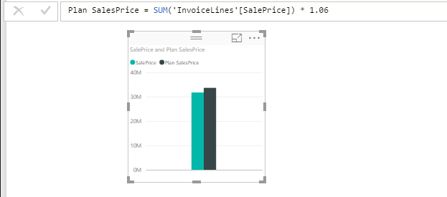

So what is the difference then between a Calculated Column and a Measure

<https://www.youtube.com/watch?v=SmXLgEHXSGc>

